TASK 6 - Testing (Software, AI, and Hardware)
1. Testing Approach & Methodology
For this project, I used two main types of testing: System Testing and User Acceptance Testing (UAT).
First, I used System Testing. This means I did not just test the laptop code or the robot hardware separately. Instead, I tested the entire connected system together. I wanted to make sure that the Python AI on the laptop could successfully send a signal to the Amazon AWS cloud, and that the cloud could instantly send that signal down to the ESP8266 microcontroller inside the physical robot on the desk.
Second, I used User Acceptance Testing (UAT) with real people. Since this project is based on Human-Centered Design (HCD), the most important part is how real users interact with it. I decided the best way to test my project was to give my packaged .exe application file to different users, have them run it on their own computers, and put my physical cardboard prototype robot on their desks.
Why is this approach suitable? This approach is perfect for my prototype because it tests real-world conditions. Running code on my own computer is easy because I built it there. But by giving the .exe file to other people, I was able to test if the software could run smoothly on different computers without needing to install any complicated Python libraries. Testing with real users also helped me see how the AI reacts to different body types, different sitting angles, and different room lighting, which I could never test all by myself.

2. Test Plan & Execution
To execute my test plan, I took my project to five different expert faculty members at the university. Because they all come from different engineering backgrounds, they could give me well-rounded feedback. My test group included:
- Dr. Dharmendrasinh Zala (Cyber Security Domain)
- Dr. Tapan Nahar (Signal Processing Domain)
- Prof. Nishit Kotak (Artificial Intelligence Domain)
- Dr. Arjab Bavarva (Cloud Computing Domain)
- Prof. Rakesh Oza (VLSI Domain)
I placed the robot on their desks, ran the .exe file on their laptops, and observed how the system worked while they did their normal work.

Test Cases and Results:
- Test Case 1: Running the Application (.exe deployment)
- Expected Result: The .exe file should open on the faculty members' laptops easily, turn on the webcam, and connect to the AWS cloud without crashing or asking for extra files.

- Actual Result: Passed. The .exe file worked perfectly on their systems. It opened smoothly and connected to the cloud right away. This proved my software packaging was successful.
- Test Case 2: Phone Distraction Detection
- Expected Result: If the user picks up their mobile phone, the AI should detect it, and the physical robot should react to remind them to focus.

- Actual Result: Passed. As shown in the attached photos, when the faculty members held up their phones, the AI successfully detected the phone and changed the status on the screen.
- Test Case 3: Live Posture Detection (Good vs. Slouching)
- Expected Result: When the user sits up straight, the screen should show "GOOD POSTURE". When they bend their back or lean too close to the screen, it should change to "SLOUCHING" and alert the robot.

- Actual Result: Mixed Results (Passed with Flaws). The system correctly identified good posture and slouching most of the time. However, the faculty testing revealed a flaw: sometimes the system had low accuracy in posture detection. If the camera angle was too low, or if the lighting in the room changed, the AI would sometimes get confused and think the user was slouching even when they were not.
Evidence of Execution: I have attached several photographic screenshots as evidence of this testing phase. The images clearly show the faculty members interacting with the system. You can see the .exe software running successfully on their laptop screens, capturing their live video feed, and displaying real-time states like "GOOD POSTURE" or "SLOUCHING". The photos also show the physical cardboard prototype robot placed on their desks, proving that the hardware and software were tested together in a real office environment.
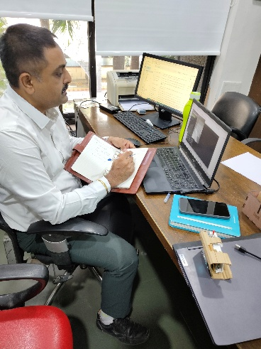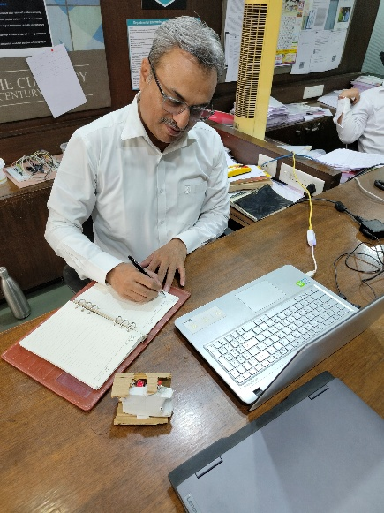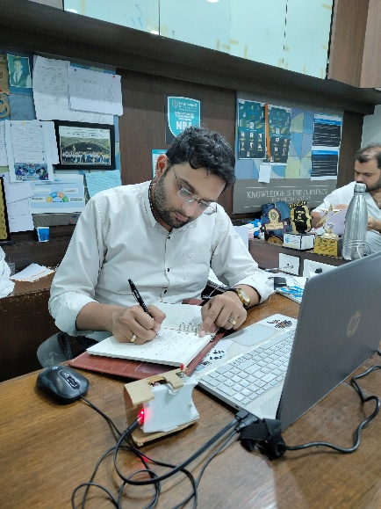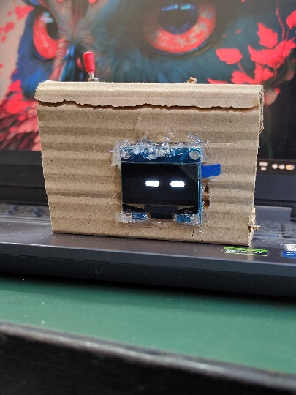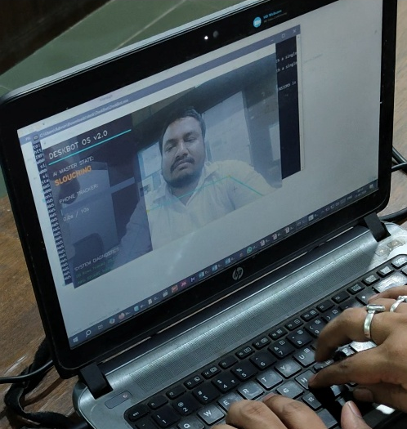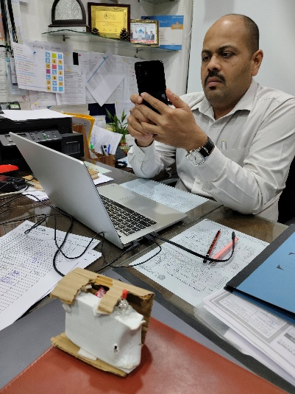
Reflection on Testing: Overall, the testing phase was a huge success. The faculty members gave me very good feedback on the concept and were impressed that the .exe file ran so smoothly and connected to the cloud without any errors. Discovering the flaw with the posture accuracy was actually a great engineering lesson. It helped me realize that machine learning models need a lot of different lighting and angle data to be perfect. This testing showed me exactly what I need to improve in the next version of my project.

